

**SEMESTER A242**

**SQIT 3073: Business Analytic Programming**

**INDIVIDUAL PROJECT**

**TITTLE :**

**TECHNICAL MANUAL: MALAYSIAN TAX INPUT PROGRAM**

**PREPARED FOR:**

DR. AMEER ADEEB

**PREPARED BY:**

MUHAMMAD DANISH IMRAN BIN MOHD AFZANIZAM

299316

**8 MAY 2025**

**1. Introduction**

This technical manual presents the Malaysian Tax Input Program, a Python-based application developed to assist users in calculating personal income tax based on Malaysian tax brackets. Designed as part of the SQIT 3073: Business Analytic Programming course, the program includes user registration, login authentication, tax computation, data storage, and reporting capabilities. This document aims to provide a complete guide to understanding, setting up, and operating the program effectively.

**2. Objective**

The main objectives of this project are:

* To develop a basic but functional tax calculation program in Python.
* To apply programming principles including modularization, file handling, and data processing.
* To demonstrate the integration of user-defined functions for authentication and calculations.
* To store user and tax data in a structured CSV format for future reference.

**3. Background**

Income tax calculations can be complex for the average citizen, especially with various brackets and reliefs. This project was developed as a learning initiative to simulate real-world programming tasks while solving a meaningful problem. By automating tax computation and storing records, the program enhances understanding of coding logic, decision-making processes, and file I/O operations in Python.

**4. Methodology / Workflow**

The system follows a clear modular approach divided across two Python files: main.py and functions.py. functions.py houses reusable logic such as user verification and tax calculation, while main.py manages the overall control flow including user interface and navigation.

**Workflow Description:**

* The program begins by showing a main menu.
* Users can register by providing a User ID, IC Number, and Password.
* Login verification checks the IC format and password validity.
* Upon successful login, users input annual income and tax relief.
* Tax is calculated based on predefined brackets.
* Results are saved to a CSV file.
* Users can choose to repeat or exit.

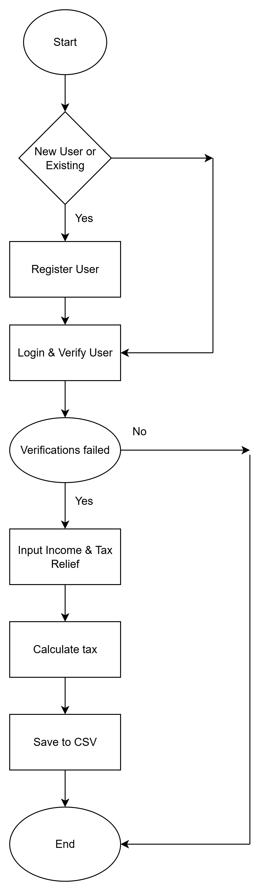

**5. Initial Setup and Configuration**

1. **Requirements:**
   * Python 3.x installed
   * pandas module installed (use pip install pandas)
2. **File Structure:**
   * main.py – main logic
   * functions.py – all function definitions
   * tax_data.csv – generated data storage (auto-created)
3. **Running the Program:**
   * Open terminal or IDE.
   * Navigate to project folder.
   * Run using: python main.py

**6. Basic Operations**

* **Registration:**  
  Users register with a unique ID and a valid 12-digit IC number.
* **Login:**  
  Credentials are verified using IC and last 4 digits as password.
* **Tax Entry:**  
  Income and relief are collected; tax is auto-computed.
* **Data Storage:**  
  Each transaction is saved into tax_data.csv.
* **Exit or Restart:**  
  User can choose to perform new calculation or exit.

**7. Troubleshooting and FAQs**

* *Q: Program doesn’t start?*
  + A: Ensure Python is installed and run from correct directory.
* *Q: ModuleNotFoundError: No module named 'pandas'?*
  + A: Run pip install pandas.
* *Q: Invalid IC or login fails?*
  + A: Make sure IC is 12 digits and password is the last 4 digits.
* *Q: CSV file not saving?*
  + A: Check write permissions in your working directory.

**8. References**

* Inland Revenue Board of Malaysia (LHDN): <https://www.hasil.gov.my/>
* Python Official Documentation: <https://docs.python.org/3/>
* Pandas Documentation: <https://pandas.pydata.org/>
* draw.io Flowchart Tool: [https://www.drawio.com](https://www.drawio.com/)
* GitHub for version control: <https://github.com/>

**GitHub Repository Link:** [**https://github.com/Danish2003Im/malaysian-tax-program**](https://github.com/yourusername/malaysian-tax-program)